18th July 2015
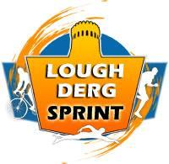

Adult €30
Junior €10
Relay €60

Registration on the Triathlon Ireland Website:
https://www.triathlonireland-newserver.com/local-races.html

Contact Maeve Ryan with any queries (0879602234 or maeveryan2007@gmail.com)

